

Bazaar

To benefit the United Women in Faith’s mission program
Saturday, November 1, 2025
9:00 a.m. – 2:00 p.m.
William Watters Memorial UMC
1452 W. Jarrettsville Road, Jarrettsville, MD 21084
8’ Space with Table & 2 chairs: $20.00

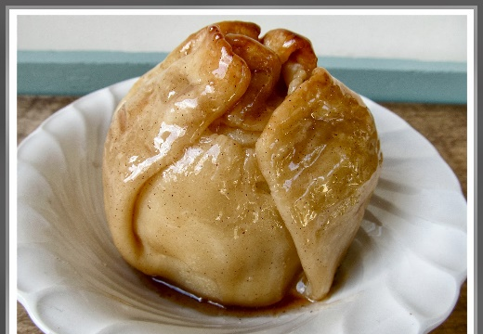
*** APPLE DUMPLINGS***



**Bake Table**
** Lunch available for purchase **
A Variety of Crafters and Vendors; Silent Auction

No alcohol or Raffles are allowed in
United Methodist Churches
For information contact Jackie 410-557-7685

